

DS.140 Design Specification

Emirates Telecommunication Group Company PJSC

**HCM Accrual Fast Formula Changes for New Joiners**

Author: Arun Batra

Creation Date: September 6, 2020

Last Updated: September 6, 2020

Document Ref: <Document Reference Number>

Version: 1.0

1. **Title, Subject, Last Updated Date, Reference Number**, **and** **Version** are marked by a Word Bookmark so that they can be easily reproduced in the header and footer of documents. When you change any of these values, be careful not to accidentally delete the bookmark. **You can make bookmarks visible by selecting the Office Button>Word Options>Advanced> and checking the Show bookmarks option in the Show document content region.**

**Approvals:**

|  |  |
| --- | --- |
| <Approver 1> | Buttar Gurmeet Singh |
| <Approver 2> |  |

1. To add additional approval lines, press [Tab] from the last cell in the table above.

oracle.gif

1. You can delete any elements of this cover page that you do not need for your document.

# Document Control

## Change Record

5

| Date | Author | Version | Change Reference |
| --- | --- | --- | --- |
| 03-Sep-20 | Arun Batra | 1.0 | No Previous Document |
|  |  |  |  |
|  |  |  |  |
|  |  |  |  |

## Reviewers

| Name | Position |
| --- | --- |
|  |  |
|  |  |
|  |  |
|  |  |

Contents

1 Document Control ii

1.1 Change Record ii

1.2 Reviewers ii

2 Technical Overview 1

3 Fast Formula 2

3.1 Correction of Fast Formula ETC_PARTIAL_PERIOD_ACCRUAL 2

3.2 Correction of Fast Formula ETC_ABSENCE_ACCRUAL_MATRIX_FF 7

3.3 Creation of Fast Formula ETC_ANNUAL_PLAN_REPROCESS 13

3.4 One Time Process to recalculate Accrual for specific staff for the last one year 23

4 Open and Closed Issues 27

4.1 Open Issues 27

4.2 Closed Issues 27

1. To update the table of contents, put the cursor anywhere in the table and press [F9]. To change the number of levels displayed, select the menu option Insert‑>Index and Tables, make sure the Table of Contents tab is active, and change the Number of Levels to a new value.

# Technical Overview

1. The purpose of this task is to assemble all the information that is required to describe the design of a software component into a complete Design Specification. This task is not a substitute for executing the individual design tasks. This specification work product can serve as a structure for completing the design for each component by providing pointers back into the Design Tasks:   
   - DS.040 Develop Design Architecture Description  
   - DS.080 Design Software Components  
   - DS.090 Design Data  
   - DS.100 Design Behavior  
   - DS.130 Design User Interface

This Design Specification documents the detailed steps for migration of Accrual Fast Formula Changes for New Joiners in production instance

1. The diagram above is just an example—Double click on it to edit it as an embedded object. Select it and choose Edit->VISIO Object->Open to open it in the full Visio application.  
     
   You can also use other tools to draw your diagram and define most of the information in this section. So you may then want to refer to the repository for a specific diagram.

# Fast Formula

## Correction of Fast Formula ETC_PARTIAL_PERIOD_ACCRUAL

Navigation to Correct Fast Formula is as follows

After Signing into Fusion as Super User, click on the Arrow on the Top Right Corner and from the Menu Option Click on “Setup and Maintenance” as in snapshot below

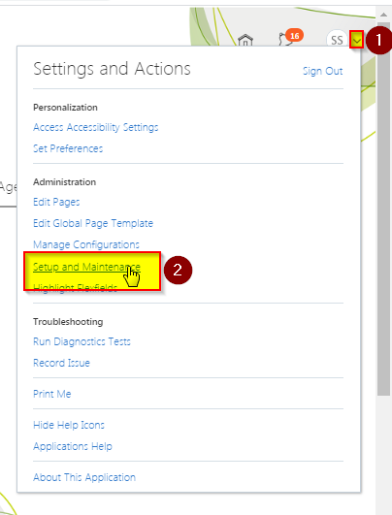

Click on the page Icon on the Right Side of the Screen, a new menu appears, choose option “Search” from the Menu as in the snapshot below

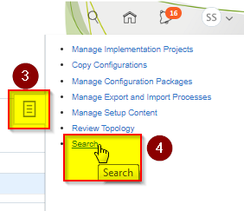

Enter “Fast Formula” in the Search Bar and Click on the Lenses icon to search for the second option “Fast Fomula” Function as in the snapshot below

Click on the link “Fast Formula” as in the snapshot below

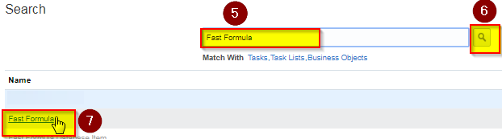

A new page opens up Click on the link “Fast Formula” again as in the snapshot below

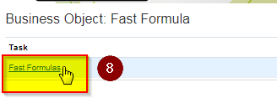

In the Formula Name Field, Enter “ETC_PARTIAL_PERIOD_ACCRUAL” and click on “Search” button to search

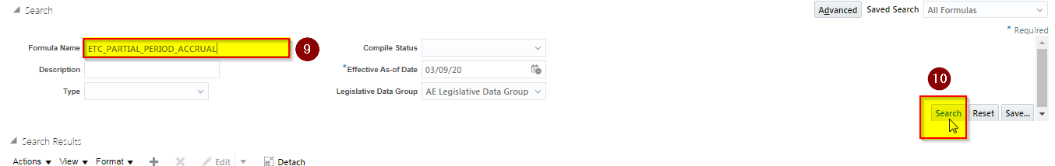

**From Search Results Click to highlight formula for** ETC_PARTIAL_PERIOD_ACCRUAL

Click on Dropdown and choose the “Correct” Option as in the snapshot below

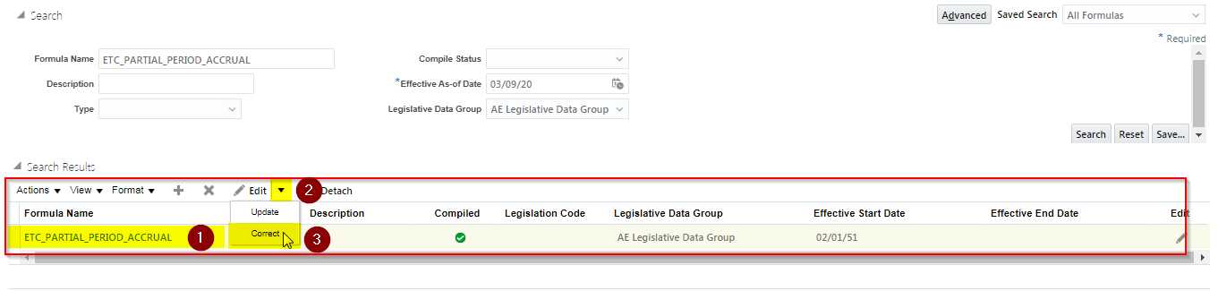

**Enter the effective Date is 02/01/51 and in the dialog box choose “OK” option as in the snapshot below**

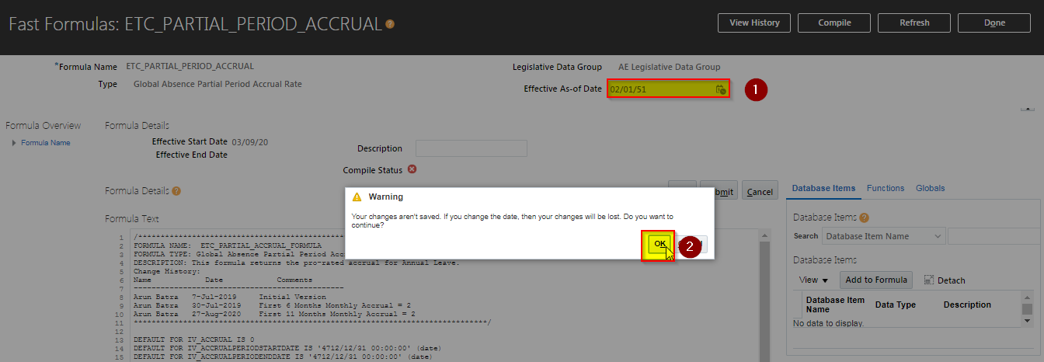

**Copy from the text below and update it in the Formula Text Region**

|  |
| --- |
| **Formula Text** |
| **/\*\*\*\*\*\*\*\*\*\*\*\*\*\*\*\*\*\*\*\*\*\*\*\*\*\*\*\*\*\*\*\*\*\*\*\*\*\*\*\*\*\*\*\*\*\*\*\*\*\*\*\*\*\*\*\*\*\*\*\*\*\*\*\*\*\*\*\*\*\*\*\*\*\*\*\*\*\***  **FORMULA NAME: ETC_PARTIAL_ACCRUAL_FORMULA**  **FORMULA TYPE: Global Absence Partial Period Accrual Rate**  **DESCRIPTION: This formula returns the pro-rated accrual for Annual Leave.**  **Change History:**  **Name Date Comments**  **-----------------------------------------------**  **Arun Batra 7-Jul-2019 Initial Version**  **Arun Batra 30-Jul-2019 First 6 Months Monthly Accrual = 2**  **Arun Batra 27-Aug-2020 First 11 Months Monthly Accrual = 2**  **\*\*\*\*\*\*\*\*\*\*\*\*\*\*\*\*\*\*\*\*\*\*\*\*\*\*\*\*\*\*\*\*\*\*\*\*\*\*\*\*\*\*\*\*\*\*\*\*\*\*\*\*\*\*\*\*\*\*\*\*\*\*\*\*\*\*\*\*\*\*\*\*\*\*\*\*\*\*\*/**  **DEFAULT FOR IV_ACCRUAL IS 0**  **DEFAULT FOR IV_ACCRUALPERIODSTARTDATE IS '4712/12/31 00:00:00' (date)**  **DEFAULT FOR IV_ACCRUALPERIODENDDATE IS '4712/12/31 00:00:00' (date)**  **DEFAULT FOR IV_CALEDARSTARTDATE IS '4712/12/31 00:00:00' (date)**  **DEFAULT FOR IV_CALEDARENDDATE IS '4712/12/31 00:00:00' (date)**  **DEFAULT FOR IV_PLANENROLLMENTSTARTDATE IS '4712/12/31 00:00:00' (date)**  **DEFAULT FOR IV_PLANENROLLMENTENDDATE IS '4712/12/31 00:00:00' (date)**  **DEFAULT FOR PER_ASG_REL_ACTUAL_TERMINATION_DATE IS '4712/12/31 00:00:00' (date)**  **DEFAULT FOR PER_ASG_FTE IS 1**  **DEFAULT FOR PER_ASG_PERSON_NUMBER IS 'X'**  **DEFAULT for PER_ASG_REL_ORIGINAL_DATE_OF_HIRE is '4712/12/31 00:00:00' (date)**  **DEFAULT FOR PER_PERSON_ENTERPRISE_HIRE_DATE IS '4712/12/31 00:00:00' (date)**  **INPUTS ARE IV_ACCRUAL**  **, IV_ACCRUALPERIODSTARTDATE (date)**  **, IV_ACCRUALPERIODENDDATE (date)**  **, IV_CALEDARSTARTDATE (date)**  **, IV_CALEDARENDDATE (date)**  **, IV_PLANENROLLMENTSTARTDATE (date)**  **, IV_PLANENROLLMENTENDDATE (date)**    **l_start_dt = TO_DATE('01-01-1951', 'dd-mm-rrrr')**  **l_end_dt = TO_DATE('01-01-1951', 'dd-mm-rrrr')**  **l_start_dt = GREATEST (IV_PLANENROLLMENTSTARTDATE,IV_ACCRUALPERIODSTARTDATE)**  **l_end_dt = LEAST (IV_PLANENROLLMENTENDDATE, IV_ACCRUALPERIODENDDATE)**  **l_hire_date = PER_PERSON_ENTERPRISE_HIRE_DATE**  **accrual = IV_ACCRUAL**  **/* Start :- If Employee Joins in mid of the Month Prorate the Accrual Value */**  **IF (MONTHS_BETWEEN(add_days(IV_ACCRUALPERIODENDDATE,1),TRUNC(l_hire_date,'MM')) >=0 AND MONTHS_BETWEEN(add_days(IV_ACCRUALPERIODENDDATE,1),TRUNC(l_hire_date,'MM')) <=11)**  **THEN**  **(**  **accrual = 2**  **)**  **ln_participation_duration = days_BETWEEN ( l_end_dt,l_start_dt)+1**  **ln_term_duration = days_BETWEEN ( IV_ACCRUALPERIODENDDATE,IV_ACCRUALPERIODSTARTDATE)+1**  **prorated_accrual = accrual * (ln_participation_duration / ln_term_duration)**  **accrual = prorated_accrual**  **/* End :- If Employee Joins in mid of the Month Prorate the Accrual Value */**    **RETURN accrual** |

**Click on “Compile” Button as in the snapshot below**

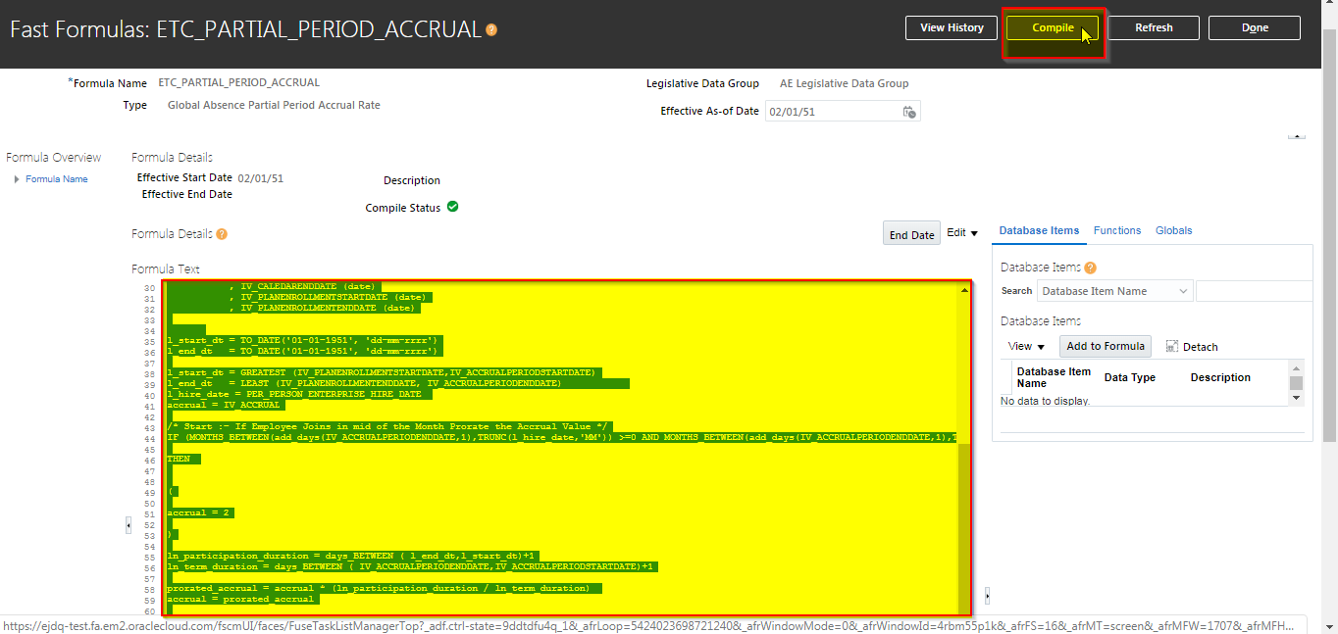

**Click on the Ok Button Next**

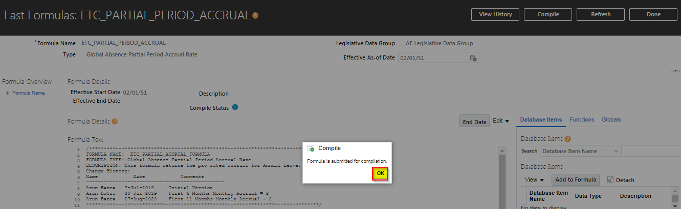

**Click on “Refresh” Button Next**

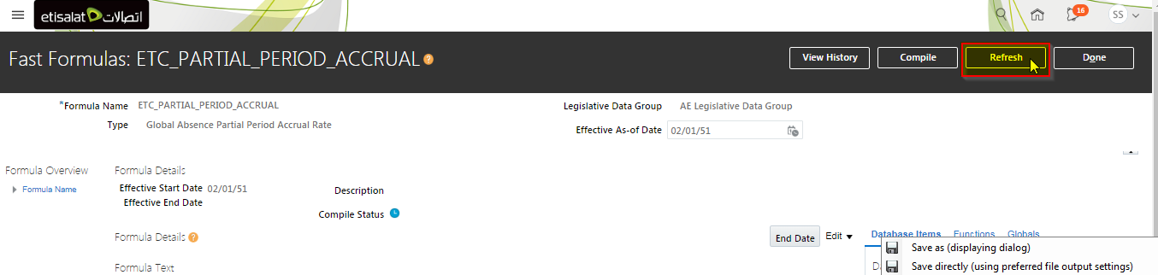

**Click on “Done” Button to close the window, this closes the Correction of Formula ETC_PARTIAL_PERIOD_ACCRUAL**

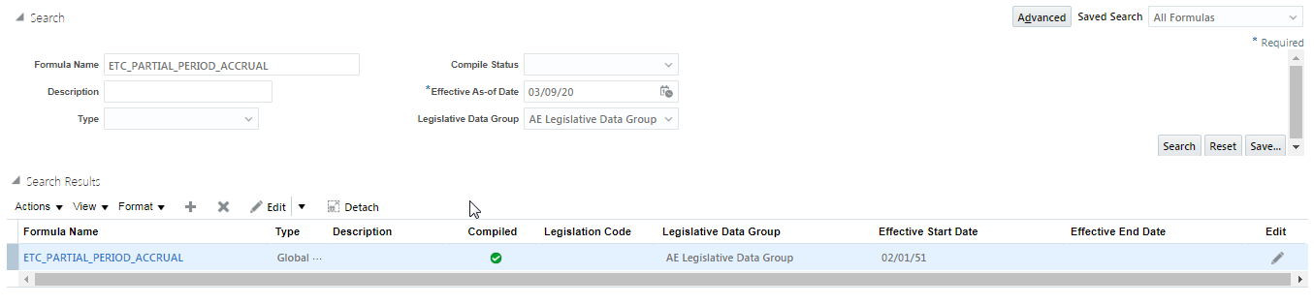

## Correction of Fast Formula ETC_ABSENCE_ACCRUAL_MATRIX_FF

**Query for “ETC_ABSENCE_ACCRUAL_MATRIX_FF” in the Formula Name Field and click on Search Button**

**After the record for “ETC_ABSENCE_ACCRUAL_MATRIX_FF” is shown, highlight the record as in step 3 and click on “Edit” Option and choose Option “Correct”**

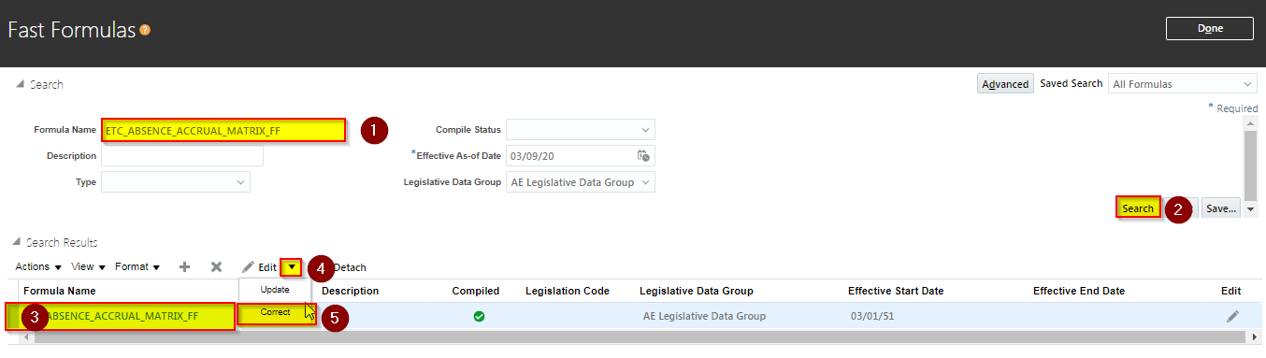

**Formula page for “ETC_ABSENCE_ACCRUAL_MATRIX_FF” will open up, change the effective date to “03/01/1951” and click on Tab, click on “OK” for the Warning dialog box**

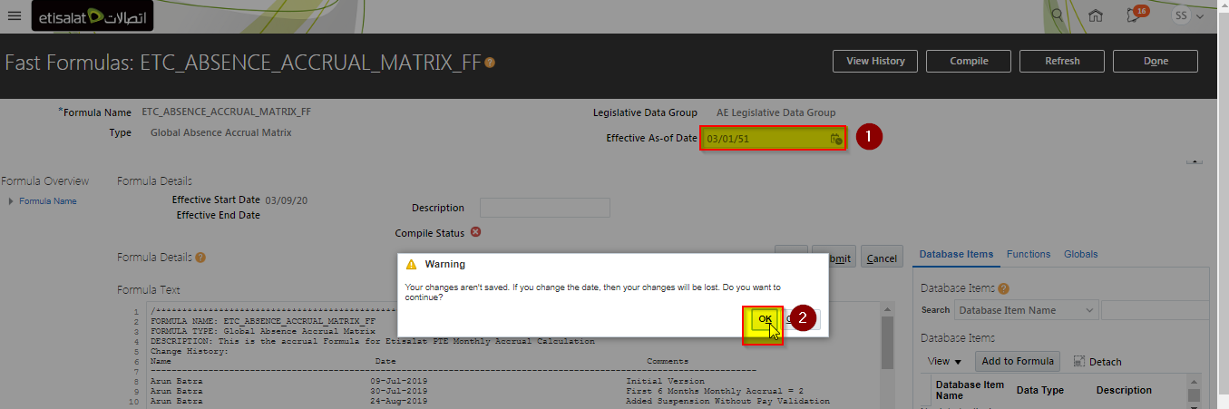

**Copy from the text below and update it in the Formula Text Region**

|  |
| --- |
| **Formula Text** |
| **/\*\*\*\*\*\*\*\*\*\*\*\*\*\*\*\*\*\*\*\*\*\*\*\*\*\*\*\*\*\*\*\*\*\*\*\*\*\*\*\*\*\*\*\*\*\*\*\*\*\*\*\*\*\*\*\*\*\*\*\*\*\*\*\*\*\*\***  **FORMULA NAME: ETC_ABSENCE_ACCRUAL_MATRIX_FF**  **FORMULA TYPE: Global Absence Accrual Matrix**  **DESCRIPTION: This is the accrual Formula for Etisalat PTE Monthly Accrual Calculation**  **Change History:**  **Name Date Comments**  **--------------------------------------------------------------------------------------------------------------------**  **Arun Batra 09-Jul-2019 Initial Version**  **Arun Batra 30-Jul-2019 First 6 Months Monthly Accrual = 2**  **Arun Batra 24-Aug-2019 Added Suspension Without Pay Validation**  **GTS 01-Aug-2020 New Joiner Accrual Change**  **Accrual Value = 2 for First 11 Months**  **Accrual Value = (0.5 x 11) + 2.5 for Final Month(12th Month)**    **GTS 27-Aug-2020 Fix for Partial Month Accrual**    **--------------------------------------------------------------------------------------------------------------------**  **\*\*\*\*\*\*\*\*\*\*\*\*\*\*\*\*\*\*\*\*\*\*\*\*\*\*\*\*\*\*\*\*\*\*\*\*\*\*\*\*\*\*\*\*\*\*\*\*\*\*\*\*\*\*\*\*\*\*\*\*\*\*\*\*\*\*\*\*\*\*\*/**  **/*=========== DATABASE ITEM DEFAULTS BEGIN =====================*/**  **DEFAULT for PER_ASG_REL_ORIGINAL_DATE_OF_HIRE is '4712/12/31 00:00:00' (date)**  **Default for PER_ASG_FTE IS 1**  **Default for IV_BAND_CHG_DT1 is '2014/03/12 00:00' (date)**  **Default for IV_BAND_CHG_BEFVAL1 is 100**  **Default for IV_BAND_CHG_AFTVAL1 is 200**  **Default for IV_ACCRUALPERIODSTARTDATE IS '4712/12/31 00:00:00' (date)**  **Default for IV_ACCRUALPERIODENDDATE IS '4712/12/31 00:00:00' (date)**  **Default for IV_CALEDARSTARTDATE IS '4712/12/31 00:00:00' (date)**  **Default for IV_CALEDARENDDATE IS '4712/12/31 00:00:00' (date)**  **Default for IV_PLANENROLLMENTSTARTDATE IS '4712/12/31 00:00:00' (date)**  **Default for IV_PLANENROLLMENTENDDATE IS '4712/12/31 00:00:00' (date)**  **DEFAULT FOR PER_ASG_PERSON_NUMBER IS 'X'**  **DEFAULT_DATA_VALUE FOR ABS_EXT_START_DATE IS '4712/12/31' (date)**  **DEFAULT_DATA_VALUE FOR ABS_EXT_END_DATE IS '4712/12/31' (date)**  **DEFAULT_DATA_VALUE FOR ABS_EXT_START_DATETIME IS '4712/12/31 00:00:00'**  **DEFAULT_DATA_VALUE FOR ABS_EXT_END_DATETIME IS '4712/12/31 00:00:00'**  **DEFAULT_DATA_VALUE FOR ABS_EXT_START_DATE_DURATION IS 0**  **DEFAULT_DATA_VALUE FOR ABS_EXT_END_DATE_DURATION IS 0**  **DEFAULT_DATA_VALUE FOR ABS_EXT_ABSENCE_TYPE_ID IS 0**  **DEFAULT_DATA_VALUE FOR ABS_EXT_ABSENCE_TYPE IS 'XX'**  **DEFAULT_DATA_VALUE FOR ABS_EXT_APPROVAL_STATUS_CD IS 'XX'**  **DEFAULT_DATA_VALUE FOR ABS_EXT_ABSENCE_STATUS_CD IS 'XX'**  **DEFAULT FOR PER_PERSON_ENTERPRISE_HIRE_DATE IS '4712/12/31 00:00:00' (date)**  **Inputs are IV_BAND_CHG_DT1**  **,IV_BAND_CHG_BEFVAL1**  **,IV_BAND_CHG_AFTVAL1**  **,IV_ACCRUAL**  **,IV_ACCRUALPERIODSTARTDATE**  **,IV_ACCRUALPERIODENDDATE**  **,IV_CALEDARSTARTDATE**  **,IV_CALEDARENDDATE**  **,IV_PLANENROLLMENTSTARTDATE**  **,IV_PLANENROLLMENTENDDATE**  **/*=========== DATABASE ITEM DEFAULTS ENDS======================*/**  **/*================ FORMULA SECTION BEGIN =======================*/**  **l_log = ESS_LOG_WRITE('PER_ASG_PERSON_NUMBER:' || PER_ASG_PERSON_NUMBER)**  **l_log = ESS_LOG_WRITE('IV_BAND_CHG_DT1: ' || TO_CHAR(IV_BAND_CHG_DT1,'DD-MON-RRRR'))**  **l_log = ESS_LOG_WRITE('IV_BAND_CHG_BEFVAL1: ' || TO_CHAR(IV_BAND_CHG_BEFVAL1))**  **l_log = ESS_LOG_WRITE('IV_BAND_CHG_AFTVAL1: ' || TO_CHAR(IV_BAND_CHG_AFTVAL1))**  **l_person_id = GET_CONTEXT(PERSON_ID,-1)**  **l_unpaid_absence_type_id = 300000002062543 /* Changed for Prod*/**  **l_susp_without_pay_abs_type_id = 300000004912716**  **accrual = IV_ACCRUAL**  **l_unpaid_Leave_days = 0**  **l_unpaid_Leave_days1 = 0**  **l_unpaid_Leave_days2 = 0**  **l_unpaid_Leave_days3 = 0**  **l_unpaid_Leave_days4 = 0**  **l_flag='N'**  **l_hire_date = PER_PERSON_ENTERPRISE_HIRE_DATE**    **/*Fix for Partial Month Accrual */**  **IF (IV_PLANENROLLMENTSTARTDATE) > trunc(l_hire_date,'MM') and TRUNC(IV_PLANENROLLMENTSTARTDATE,'MM') != TRUNC (IV_ACCRUALPERIODENDDATE,'MM') then**  **(**  **l_hire_date = add_months(l_hire_date,1)**  **)**      **/* Accrual is 2 for First 11 months from Hire Date CR 2 */**    **IF (MONTHS_BETWEEN(add_days(IV_ACCRUALPERIODENDDATE,1),TRUNC(l_hire_date,'MM')) >=0**  **AND MONTHS_BETWEEN(add_days(IV_ACCRUALPERIODENDDATE,1),TRUNC(l_hire_date,'MM')) <=11) and l_hire_date >= '2019/01/01 00:00:00' (date)**  **THEN**  **(**  **accrual = 2**  **)**  **/* Accrual is 2 for First 11 months from Hire Date - CR 2 */**  **/* Accrual to be given in 11th month = 0.5 x 11 plus 2.5 Accrual of 12th Month CR-2*/**  **IF MONTHS_BETWEEN(add_days(IV_ACCRUALPERIODENDDATE,1),TRUNC(l_hire_date,'MM')) = 12 and l_hire_date >= '2019/01/01 00:00:00' (date)**  **THEN**  **(**  **accrual = IV_ACCRUAL + (MONTHS_BETWEEN(IV_ACCRUALPERIODSTARTDATE,TRUNC(l_hire_date)) * 0.5)**  **)**  **/* Accrual to be given in 12th month = 0.5 x 11 plus 2.5 Accrual of 12th Month CR-2*/**  **l_log = ESS_LOG_WRITE('ETC_ABSENCE_ACCRUAL_MATRIX_FF IV_ACCRUALPERIODSTARTDATE ' || TO_CHAR(IV_ACCRUALPERIODSTARTDATE))**  **l_log = ESS_LOG_WRITE('ETC_ABSENCE_ACCRUAL_MATRIX_FF IV_ACCRUALPERIODENDDATE ' || TO_CHAR(IV_ACCRUALPERIODENDDATE))**  **/* Start :- Logic to Retreive the Unpaid Leave */**  **CHANGE_CONTEXTS(PERSON_ID = l_person_id ,EFFECTIVE_DATE = trunc(IV_ACCRUALPERIODSTARTDATE))**  **(**  **I=1**  **WHILE ABS_EXT_ABSENCE_TYPE_ID.EXISTS(I)**  **LOOP**  **(**    **IF (**  **( trunc(ABS_EXT_START_DATE[I]) >= trunc(IV_ACCRUALPERIODSTARTDATE) AND trunc(ABS_EXT_END_DATE[I]) <= trunc(IV_ACCRUALPERIODENDDATE)**  **AND UPPER(ABS_EXT_ABSENCE_STATUS_CD[I])!= 'ORA_WITHDRAWN')**  **AND (ABS_EXT_ABSENCE_TYPE_ID[I] = l_unpaid_absence_type_id OR ABS_EXT_ABSENCE_TYPE_ID[I] = l_susp_without_pay_abs_type_id))**  **THEN**  **(**  **l_flag='Y'**  **l_unpaid_Leave_days1 = l_unpaid_Leave_days1 + DAYS_BETWEEN(trunc(ABS_EXT_END_DATE[I]),trunc(ABS_EXT_START_DATE[I]))+1**  **l_log = ESS_LOG_WRITE('ETC_ABSENCE_ACCRUAL_MATRIX_FF l_unpaid_Leave_days1 ' || TO_CHAR(l_unpaid_Leave_days1))**    **)**  **IF (**  **( trunc(ABS_EXT_START_DATE[I]) < trunc(IV_ACCRUALPERIODSTARTDATE) AND (trunc(ABS_EXT_END_DATE[I]) <= trunc(IV_ACCRUALPERIODENDDATE)**  **and trunc(ABS_EXT_END_DATE[I]) > trunc(IV_ACCRUALPERIODSTARTDATE))AND UPPER(ABS_EXT_ABSENCE_STATUS_CD[I])!= 'ORA_WITHDRAWN')**  **AND (ABS_EXT_ABSENCE_TYPE_ID[I] = l_unpaid_absence_type_id OR ABS_EXT_ABSENCE_TYPE_ID[I] = l_susp_without_pay_abs_type_id) )**  **THEN**  **(**  **l_flag='Y'**  **l_unpaid_Leave_days2 = l_unpaid_Leave_days2 + DAYS_BETWEEN(trunc(ABS_EXT_END_DATE[I]),trunc(IV_ACCRUALPERIODSTARTDATE))+1**  **l_log = ESS_LOG_WRITE('ETC_ABSENCE_ACCRUAL_MATRIX_FF l_unpaid_Leave_days2 ' || TO_CHAR(l_unpaid_Leave_days2))**  **)**  **IF( (**  **( trunc(ABS_EXT_START_DATE[I]) > trunc(IV_ACCRUALPERIODSTARTDATE) and trunc(ABS_EXT_START_DATE[I]) <= trunc(IV_ACCRUALPERIODENDDATE) )**  **AND trunc(ABS_EXT_END_DATE[I]) > trunc(IV_ACCRUALPERIODENDDATE)**  **AND UPPER(ABS_EXT_ABSENCE_STATUS_CD[I])!= 'ORA_WITHDRAWN') AND (ABS_EXT_ABSENCE_TYPE_ID[I] = l_unpaid_absence_type_id**  **OR ABS_EXT_ABSENCE_TYPE_ID[I] = l_susp_without_pay_abs_type_id) )**  **THEN**  **(**  **l_flag='Y'**  **l_unpaid_Leave_days3 = l_unpaid_Leave_days3 + DAYS_BETWEEN(trunc(IV_ACCRUALPERIODENDDATE),trunc(ABS_EXT_START_DATE[I]))+1**  **l_log = ESS_LOG_WRITE('ETC_ABSENCE_ACCRUAL_MATRIX_FF l_unpaid_Leave_days3 ' || TO_CHAR(l_unpaid_Leave_days3))**  **)**  **IF (**  **( trunc(ABS_EXT_START_DATE[I]) < trunc(IV_ACCRUALPERIODSTARTDATE) AND trunc(ABS_EXT_END_DATE[I]) > trunc(IV_ACCRUALPERIODENDDATE)**  **AND UPPER(ABS_EXT_ABSENCE_STATUS_CD[I])!= 'ORA_WITHDRAWN') AND (ABS_EXT_ABSENCE_TYPE_ID[I] = l_unpaid_absence_type_id**  **OR ABS_EXT_ABSENCE_TYPE_ID[I] = l_susp_without_pay_abs_type_id) )**  **THEN**  **(**  **l_flag='Y'**  **l_unpaid_Leave_days4 = l_unpaid_Leave_days4 + DAYS_BETWEEN(trunc(IV_ACCRUALPERIODENDDATE),trunc(IV_ACCRUALPERIODSTARTDATE))+1**  **l_log = ESS_LOG_WRITE('ETC_ABSENCE_ACCRUAL_MATRIX_FF l_unpaid_Leave_days4 ' || TO_CHAR(l_unpaid_Leave_days4))**  **)**  **I=I+1**  **)**  **l_unpaid_Leave_days = l_unpaid_Leave_days1 + l_unpaid_Leave_days2 + l_unpaid_Leave_days3 + l_unpaid_Leave_days4**  **)**  **/* End :- Logic to Retreive the Unpaid Leave */**  **l_log = ESS_LOG_WRITE('test l_unpaid_Leave_days ' || TO_CHAR(l_unpaid_Leave_days))**  **/* Start :- Unpaid Leave exists then reduce the Accrual value */**  **IF l_unpaid_Leave_days > 0 THEN**  **(**  **L_ACCRUAL_FACTOR = ((DAYS_BETWEEN(trunc(IV_ACCRUALPERIODENDDATE),trunc(IV_ACCRUALPERIODSTARTDATE))+1)-l_unpaid_Leave_days)/(DAYS_BETWEEN(trunc(IV_ACCRUALPERIODENDDATE),trunc(IV_ACCRUALPERIODSTARTDATE))+1)**  **l_log = ESS_LOG_WRITE('ETC_ABSENCE_ACCRUAL_MATRIX_FF L_ACCRUAL_FACTOR ' || TO_CHAR(L_ACCRUAL_FACTOR))**  **accrual = accrual * L_ACCRUAL_FACTOR**  **l_log = ESS_LOG_WRITE('ETC_ABSENCE_ACCRUAL_MATRIX_FF accrual ' || TO_CHAR(accrual))**  **)**  **/* End :- Unpaid Leave exists then reduce the Accrual value */**  **l_log = ESS_LOG_WRITE('ETC_ABSENCE_ACCRUAL_MATRIX_FF Outside IF')**  **l_log = ESS_LOG_WRITE('ETC_ABSENCE_ACCRUAL_MATRIX_FF accrual ' || TO_CHAR(accrual))**  **return accrual** |

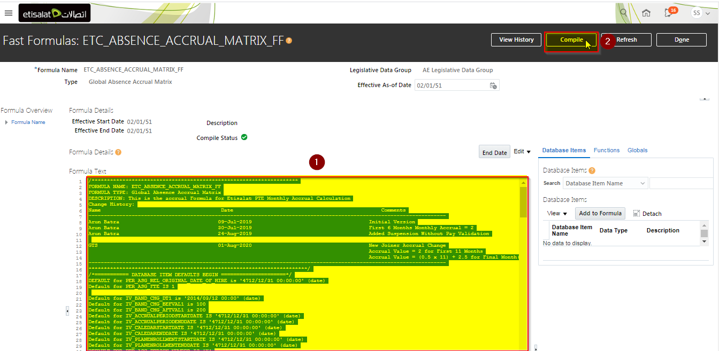

**Click on “Ok” button in the dialog box for Compile**

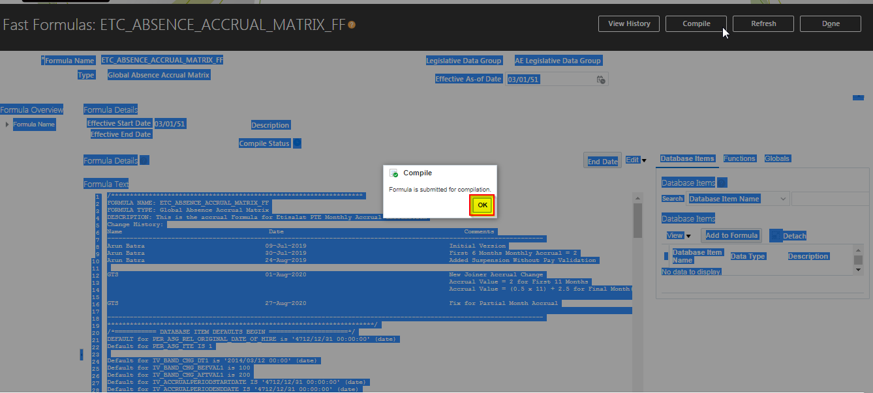

**Click on “Refresh” Button the status of Compile should change now from Green ”Clock” to green “Check”**

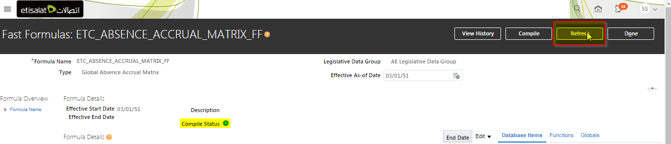

**Finally click on “Done” to close the correction of formula ETC_ABSENCE_ACCRUAL_MATRIX_FF**

1. The intent of this section is to define the details of each operation (to include pseudo code) required for each entity, module, or class within the component. Refer to Behavior Design (DS.100) and the Design class diagram, with a focus specifically on the Operations section for the Class. In the event that you do not have a class diagram use the table below.

## Creation of Fast Formula ETC_ANNUAL_PLAN_REPROCESS

**Query for “ETC_ABSENCE_PLAN_REPROCESS” in the Formula Name Field and click on Search Button**

**No Record will be visible, click on “Plus” Symbol as in the snapshot below to create new Fast Formula**

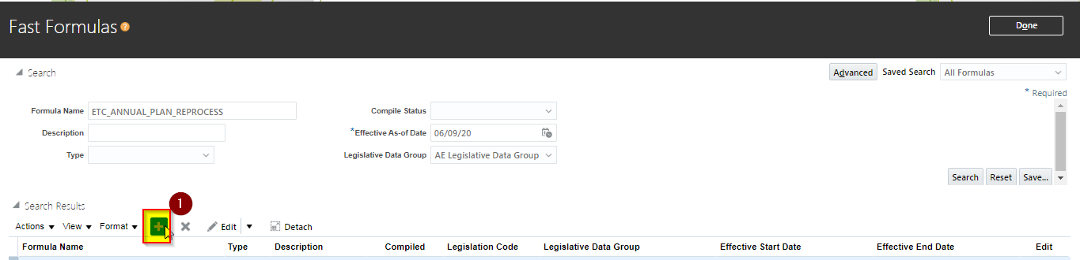

In a new Formula pop up window, enter following details

|  |  |
| --- | --- |
| Formula Name | ETC_ANNUAL_PLAN_REPROCESS |
| Type | Person Selection |
| Legislative Data Group | AE Legislative Data Group |
| Effective Start Date | 01/01/1951 |

After entering details, click on Continue button as in the snapshot below, this will open another window in which we will enter the Formula

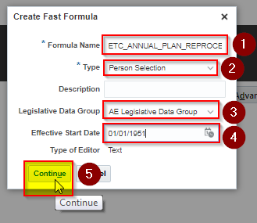

After new window opens up, enter Formula Text as in the Details after the snapshot and click on “Save” Button

**Copy from the text below and update it in the Formula Text Region**

|  |
| --- |
| **Formula Text** |
| **/* FORMULA NAME: ETC_ANNUAL_PLAN_REPROCESS**  **FORMULA TYPE: Person Selection**  **DESCRIPTION: The formula selects employees based on person numbers.**  **Change History:**  **Name Date Comments**  **-----------------------------------------------**  **GTS 01-SEP-2020 Initial Version**    **\*/**  **/*=========== DATABASE ITEM DEFAULTS BEGIN =====================*/**  **DEFAULT FOR PER_ASG_PERSON_NUMBER IS ' '**  **/*=========== DATABASE ITEM DEFAULTS ENDS======================*/**  **/*================ FORMULA SECTION BEGIN =======================*/**  **l_output = 'N'**  **l_person_num = PER_ASG_PERSON_NUMBER**  **IF (**  **l_person_num = '504290' OR**  **l_person_num = '504418' OR**  **l_person_num = '504890' OR**  **l_person_num = '504446' OR**  **l_person_num = '504451' OR**  **l_person_num = '504460' OR**  **l_person_num = '504314' OR**  **l_person_num = '504529' OR**  **l_person_num = '504734' OR**  **l_person_num = '504534' OR**  **l_person_num = '504419' OR**  **l_person_num = '504765' OR**  **l_person_num = '504731' OR**  **l_person_num = '504720' OR**  **l_person_num = '504542' OR**  **l_person_num = '504461' OR**  **l_person_num = '504395' OR**  **l_person_num = '504397' OR**  **l_person_num = '504530' OR**  **l_person_num = '504462' OR**  **l_person_num = '504335' OR**  **l_person_num = '504331' OR**  **l_person_num = '504793' OR**  **l_person_num = '504725' OR**  **l_person_num = '504791' OR**  **l_person_num = '504737' OR**  **l_person_num = '504783' OR**  **l_person_num = '504910' OR**  **l_person_num = '504493' OR**  **l_person_num = '504307' OR**  **l_person_num = '504608' OR**  **l_person_num = '504827' OR**  **l_person_num = '504600' OR**  **l_person_num = '504499' OR**  **l_person_num = '504411' OR**  **l_person_num = '504412' OR**  **l_person_num = '504524' OR**  **l_person_num = '504864' OR**  **l_person_num = '504358' OR**  **l_person_num = '504405' OR**  **l_person_num = '504816' OR**  **l_person_num = '504601' OR**  **l_person_num = '504900' OR**  **l_person_num = '504468' OR**  **l_person_num = '504823' OR**  **l_person_num = '504868' OR**  **l_person_num = '504312' OR**  **l_person_num = '504430' OR**  **l_person_num = '504449' OR**  **l_person_num = '504356' OR**  **l_person_num = '504390' OR**  **l_person_num = '504308' OR**  **l_person_num = '504296' OR**  **l_person_num = '504891' OR**  **l_person_num = '504303' OR**  **l_person_num = '504318' OR**  **l_person_num = '504571' OR**  **l_person_num = '504792' OR**  **l_person_num = '504407' OR**  **l_person_num = '504882' OR**  **l_person_num = '504560' OR**  **l_person_num = '504795' OR**  **l_person_num = '504320' OR**  **l_person_num = '504291' OR**  **l_person_num = '504302' OR**  **l_person_num = '504551' OR**  **l_person_num = '504899' OR**  **l_person_num = '504517' OR**  **l_person_num = '504347' OR**  **l_person_num = '504326' OR**  **l_person_num = '504458' OR**  **l_person_num = '504897' OR**  **l_person_num = '504346' OR**  **l_person_num = '504353' OR**  **l_person_num = '504796' OR**  **l_person_num = '504300' OR**  **l_person_num = '504598' OR**  **l_person_num = '504799' OR**  **l_person_num = '504304' OR**  **l_person_num = '504565' OR**  **l_person_num = '504787' OR**  **l_person_num = '504747' OR**  **l_person_num = '504779' OR**  **l_person_num = '504730' OR**  **l_person_num = '504803' OR**  **l_person_num = '504568' OR**  **l_person_num = '504772' OR**  **l_person_num = '504614' OR**  **l_person_num = '504782' OR**  **l_person_num = '504817' OR**  **l_person_num = '504467' OR**  **l_person_num = '504786' OR**  **l_person_num = '504421' OR**  **l_person_num = '504410' OR**  **l_person_num = '504301' OR**  **l_person_num = '504853' OR**  **l_person_num = '504543' OR**  **l_person_num = '504539' OR**  **l_person_num = '504562' OR**  **l_person_num = '504802' OR**  **l_person_num = '504759' OR**  **l_person_num = '504818' OR**  **l_person_num = '504376' OR**  **l_person_num = '504511' OR**  **l_person_num = '504537' OR**  **l_person_num = '504889' OR**  **l_person_num = '504908' OR**  **l_person_num = '504297' OR**  **l_person_num = '504351' OR**  **l_person_num = '504570' OR**  **l_person_num = '504352' OR**  **l_person_num = '504758' OR**  **l_person_num = '504777' OR**  **l_person_num = '504484' OR**  **l_person_num = '504323' OR**  **l_person_num = '504444' OR**  **l_person_num = '504707' OR**  **l_person_num = '504766' OR**  **l_person_num = '504810' OR**  **l_person_num = '504355' OR**  **l_person_num = '504822' OR**  **l_person_num = '504364' OR**  **l_person_num = '504427' OR**  **l_person_num = '504416' OR**  **l_person_num = '504776' OR**  **l_person_num = '504338' OR**  **l_person_num = '504746' OR**  **l_person_num = '504457' OR**  **l_person_num = '504469' OR**  **l_person_num = '504495' OR**  **l_person_num = '504508' OR**  **l_person_num = '504767' OR**  **l_person_num = '504330' OR**  **l_person_num = '504878' OR**  **l_person_num = '504576' OR**  **l_person_num = '504887' OR**  **l_person_num = '504585' OR**  **l_person_num = '504546' OR**  **l_person_num = '504699' OR**  **l_person_num = '504717' OR**  **l_person_num = '504701' OR**  **l_person_num = '504858' OR**  **l_person_num = '504518' OR**  **l_person_num = '504525' OR**  **l_person_num = '504417' OR**  **l_person_num = '504554' OR**  **l_person_num = '504778' OR**  **l_person_num = '504739' OR**  **l_person_num = '504862' OR**  **l_person_num = '504901' OR**  **l_person_num = '504425' OR**  **l_person_num = '504781' OR**  **l_person_num = '504763' OR**  **l_person_num = '504774' OR**  **l_person_num = '504869' OR**  **l_person_num = '504700' OR**  **l_person_num = '504762' OR**  **l_person_num = '504798' OR**  **l_person_num = '504409' OR**  **l_person_num = '504545' OR**  **l_person_num = '504820' OR**  **l_person_num = '504871' OR**  **l_person_num = '504880' OR**  **l_person_num = '504536' OR**  **l_person_num = '504538' OR**  **l_person_num = '504544' OR**  **l_person_num = '504801' OR**  **l_person_num = '504893' OR**  **l_person_num = '504892' OR**  **l_person_num = '504895' OR**  **l_person_num = '504557' OR**  **l_person_num = '504550' OR**  **l_person_num = '504559' OR**  **l_person_num = '504510' OR**  **l_person_num = '504804' OR**  **l_person_num = '504807' OR**  **l_person_num = '504716' OR**  **l_person_num = '504501' OR**  **l_person_num = '504828' OR**  **l_person_num = '504808' OR**  **l_person_num = '504736' OR**  **l_person_num = '504305' OR**  **l_person_num = '504424' OR**  **l_person_num = '504740' OR**  **l_person_num = '504664' OR**  **l_person_num = '504894' OR**  **l_person_num = '504906' OR**  **l_person_num = '504313' OR**  **l_person_num = '504403' OR**  **l_person_num = '504377' OR**  **l_person_num = '504348' OR**  **l_person_num = '504465' OR**  **l_person_num = '504402' OR**  **l_person_num = '504533' OR**  **l_person_num = '504463' OR**  **l_person_num = '504522' OR**  **l_person_num = '504723' OR**  **l_person_num = '504698' OR**  **l_person_num = '504855' OR**  **l_person_num = '504722' OR**  **l_person_num = '504482' OR**  **l_person_num = '504520' OR**  **l_person_num = '504485' OR**  **l_person_num = '504610' OR**  **l_person_num = '504584' OR**  **l_person_num = '504426' OR**  **l_person_num = '504483' OR**  **l_person_num = '504876' OR**  **l_person_num = '504443' OR**  **l_person_num = '504879' OR**  **l_person_num = '504527' OR**  **l_person_num = '504875' OR**  **l_person_num = '504450' OR**  **l_person_num = '504440' OR**  **l_person_num = '504324' OR**  **l_person_num = '504435' OR**  **l_person_num = '504790' OR**  **l_person_num = '504478' OR**  **l_person_num = '504788' OR**  **l_person_num = '504741' OR**  **l_person_num = '504558' OR**  **l_person_num = '504396' OR**  **l_person_num = '504599' OR**  **l_person_num = '504361' OR**  **l_person_num = '504874' OR**  **l_person_num = '504755' OR**  **l_person_num = '504521' OR**  **l_person_num = '504448' OR**  **l_person_num = '504591' OR**  **l_person_num = '504815' OR**  **l_person_num = '504866' OR**  **l_person_num = '504408' OR**  **l_person_num = '504663' OR**  **l_person_num = '504811' OR**  **l_person_num = '504496' OR**  **l_person_num = '504341' OR**  **l_person_num = '504867' OR**  **l_person_num = '504819' OR**  **l_person_num = '504325' OR**  **l_person_num = '504898' OR**  **l_person_num = '504295' OR**  **l_person_num = '504732' OR**  **l_person_num = '504756' OR**  **l_person_num = '504719' OR**  **l_person_num = '504400' OR**  **l_person_num = '504447' OR**  **l_person_num = '504813' OR**  **l_person_num = '504826' OR**  **l_person_num = '504814' OR**  **l_person_num = '504724' OR**  **l_person_num = '504809' OR**  **l_person_num = '504745' OR**  **l_person_num = '504883' OR**  **l_person_num = '504431' OR**  **l_person_num = '504316' OR**  **l_person_num = '504812' OR**  **l_person_num = '504668' OR**  **l_person_num = '504413' OR**  **l_person_num = '504671' OR**  **l_person_num = '504797' OR**  **l_person_num = '504385' OR**  **l_person_num = '504743' OR**  **l_person_num = '504670' OR**  **l_person_num = '504744' OR**  **l_person_num = '504429' OR**  **l_person_num = '504393' OR**  **l_person_num = '504587' OR**  **l_person_num = '504466' OR**  **l_person_num = '504391' OR**  **l_person_num = '504612' OR**  **l_person_num = '504328' OR**  **l_person_num = '504362' OR**  **l_person_num = '504439' OR**  **l_person_num = '504488' OR**  **l_person_num = '504531' OR**  **l_person_num = '504805' OR**  **l_person_num = '504509' OR**  **l_person_num = '504433' OR**  **l_person_num = '504523' OR**  **l_person_num = '504665' OR**  **l_person_num = '504574' OR**  **l_person_num = '504298' OR**  **l_person_num = '504582' OR**  **l_person_num = '504319' OR**  **l_person_num = '504549' OR**  **l_person_num = '504872' OR**  **l_person_num = '504754' OR**  **l_person_num = '504357' OR**  **l_person_num = '504452' OR**  **l_person_num = '504563' OR**  **l_person_num = '504459' OR**  **l_person_num = '504609' OR**  **l_person_num = '504398' OR**  **l_person_num = '504662' OR**  **l_person_num = '504336' OR**  **l_person_num = '504873' OR**  **l_person_num = '504528' OR**  **l_person_num = '504611' OR**  **l_person_num = '504321' OR**  **l_person_num = '504519' OR**  **l_person_num = '504535' OR**  **l_person_num = '504532' OR**  **l_person_num = '504487' OR**  **l_person_num = '504399' OR**  **l_person_num = '504422' OR**  **l_person_num = '504785' OR**  **l_person_num = '504404' OR**  **l_person_num = '504454' OR**  **l_person_num = '504491' OR**  **l_person_num = '504375' OR**  **l_person_num = '504486' OR**  **l_person_num = '504848' OR**  **l_person_num = '504794' OR**  **l_person_num = '504437' OR**  **l_person_num = '504780' OR**  **l_person_num = '504344' OR**  **l_person_num = '504588' OR**  **l_person_num = '504824' OR**  **l_person_num = '504771' OR**  **l_person_num = '504365' OR**  **l_person_num = '504603' OR**  **l_person_num = '504306' OR**  **l_person_num = '504602' OR**  **l_person_num = '504870' OR**  **l_person_num = '504884' OR**  **l_person_num = '504455' OR**  **l_person_num = '504315' OR**  **l_person_num = '504845' OR**  **l_person_num = '504322' OR**  **l_person_num = '504821' OR**  **l_person_num = '504541' OR**  **l_person_num = '504453' OR**  **l_person_num = '504480' OR**  **l_person_num = '504503' OR**  **l_person_num = '504512' OR**  **l_person_num = '504881' OR**  **l_person_num = '504526' OR**  **l_person_num = '504800' OR**  **l_person_num = '504489' OR**  **l_person_num = '504470' OR**  **l_person_num = '504775' OR**  **l_person_num = '504637' OR**  **l_person_num = '504877' OR**  **l_person_num = '504350' OR**  **l_person_num = '504729' OR**  **l_person_num = '504337' OR**  **l_person_num = '504490' OR**  **l_person_num = '504343' OR**  **l_person_num = '504764' OR**  **l_person_num = '504340' OR**  **l_person_num = '504742' OR**  **l_person_num = '504806' OR**  **l_person_num = '504592' OR**  **l_person_num = '504573' OR**  **l_person_num = '504389' OR**  **l_person_num = '504392' OR**  **l_person_num = '504583' OR**  **l_person_num = '504553' OR**  **l_person_num = '504515' OR**  **l_person_num = '504580' OR**  **l_person_num = '504309' OR**  **l_person_num = '504773' OR**  **l_person_num = '504784' OR**  **l_person_num = '504556' OR**  **l_person_num = '504432' OR**  **l_person_num = '504327' OR**  **l_person_num = '504789' OR**  **l_person_num = '504586' OR**  **l_person_num = '504445' OR**  **l_person_num = '504394' OR**  **l_person_num = '504738' OR**  **l_person_num = '504516' OR**  **l_person_num = '504299' OR**  **l_person_num = '504854' OR**  **l_person_num = '504579' OR**  **l_person_num = '504504' OR**  **l_person_num = '504578' OR**  **l_person_num = '504477' OR**  **l_person_num = '504436' OR**  **l_person_num = '504896' OR**  **l_person_num = '504596' OR**  **l_person_num = '504317' OR**  **l_person_num = '504456' OR**  **l_person_num = '504567' OR**  **l_person_num = '504498'**  **) THEN**  **(l_output = 'Y')**  **ELSE**  **(l_output = 'N')**  **L_RETURN = l_output**  **RETURN L_RETURN** |

After entering the formula and click on save button and then the compile button

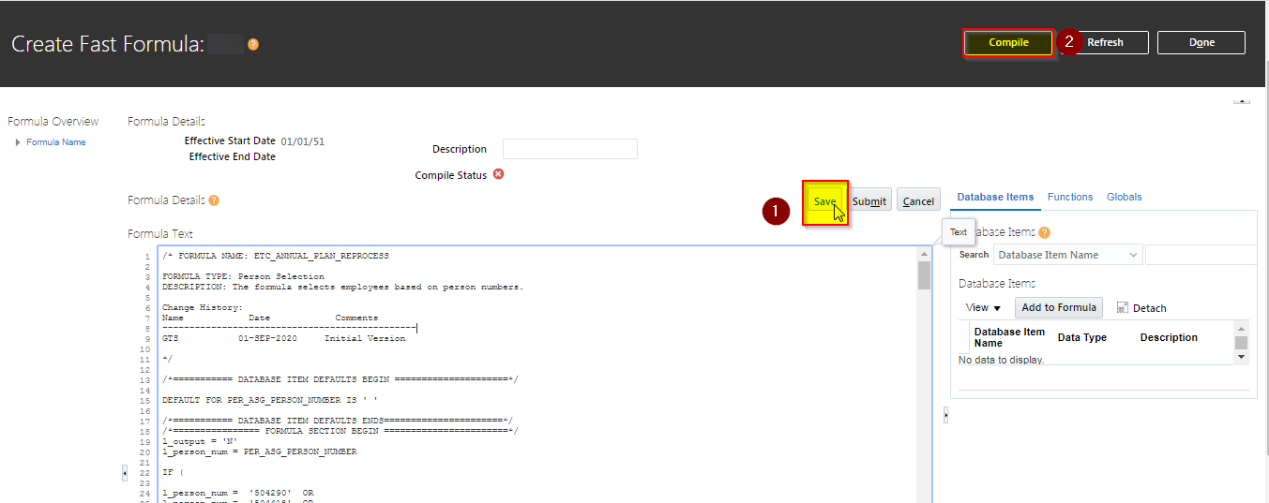

After clicking on compile button, a pop up shows up, click on “Ok” button

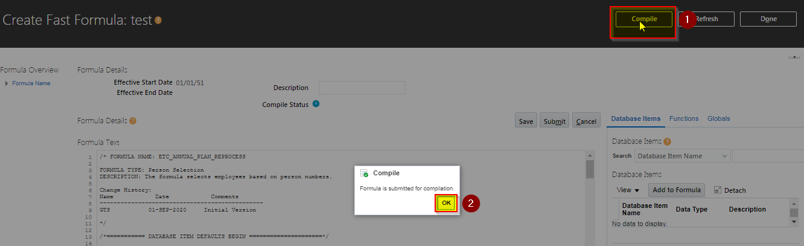

Finally click on “Refresh” button

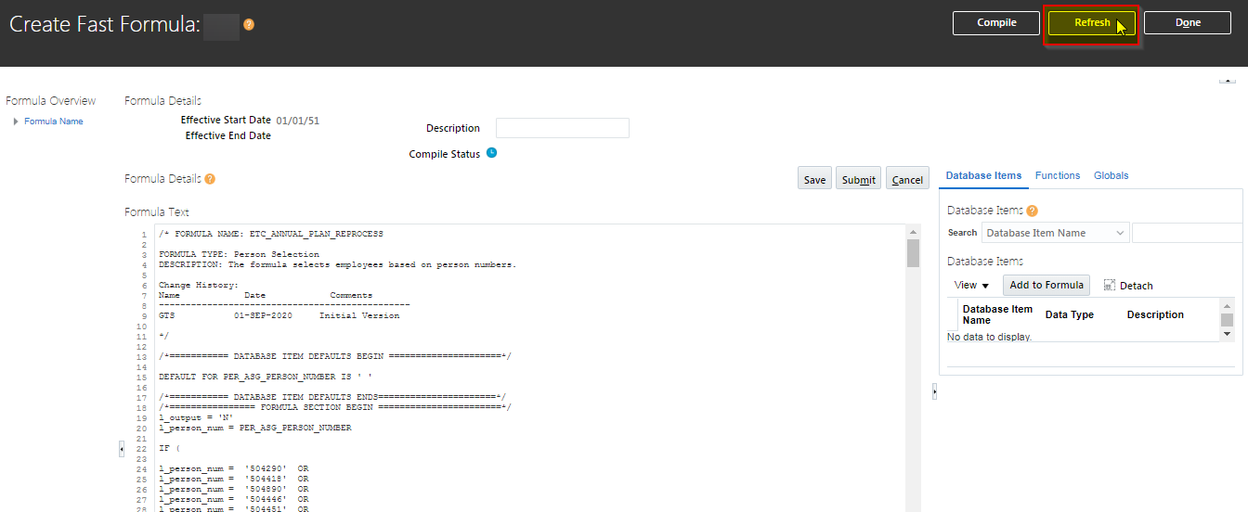

After clicking on “Refresh” Button, the Compile Status will change to “Green Check” as in the snapshot below, this closes the Fast Formula entry. Click on “Done” button to close the window.

## One Time Process to recalculate Accrual for specific staff for the last one year

To Reprocess Accrual for staff who have not completed one year Service, execute the following program with relevant parameters each time with different effective date as in the table below

|  |  |
| --- | --- |
| Name | Calculate Accruals and Balances |
| Effective Date | 31/08/2019 |
| Effective Date | 30/09/2019 |
| Effective Date | 31/10/2019 |
| Effective Date | 30/11/2019 |
| Effective Date | 31/12/2019 |
| Effective Date | 31/01/2020 |
| Effective Date | 29/02/2020 |
| Effective Date | 31/03/2020 |
| Effective Date | 30/04/2020 |
| Effective Date | 31/05/2020 |
| Effective Date | 30/06/2020 |
| Effective Date | 31/07/2020 |
| Effective Date | 31/08/2020 |
| Process Selection Rule | ETC_ANNUAL_PLAN_REPROCESS |

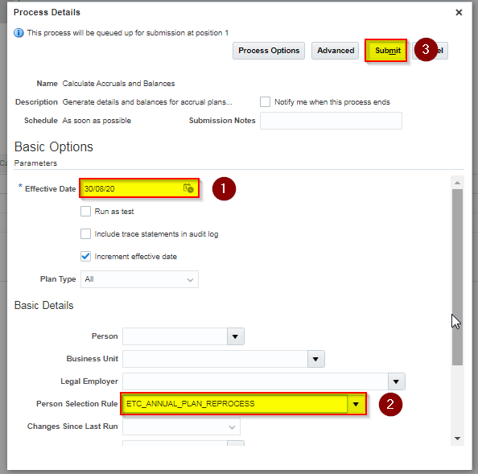

Steps to Execute Each program is as follows

Click on Menu Option from Top Left🡪 click and expand on “Tools” Region 🡪 click on “Scheduled Processes” as in the snapshot below

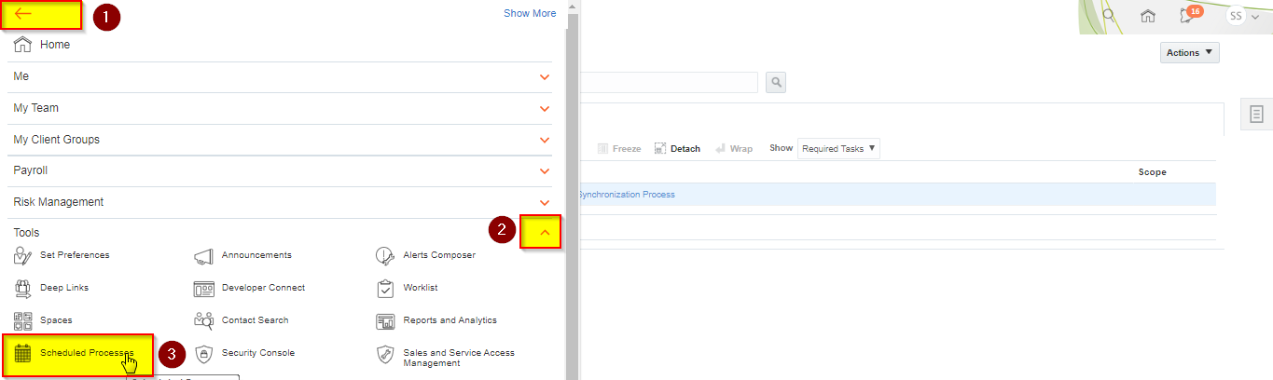

A new page opens up where we can submit a program, click on button “Schedule New Process”

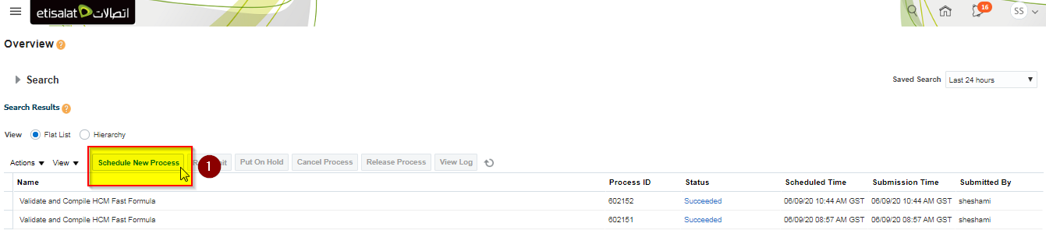

A pop up window opens up, choose option “Job” and enter “Calculate Accruals and Balances” in Name Field and click on Ok

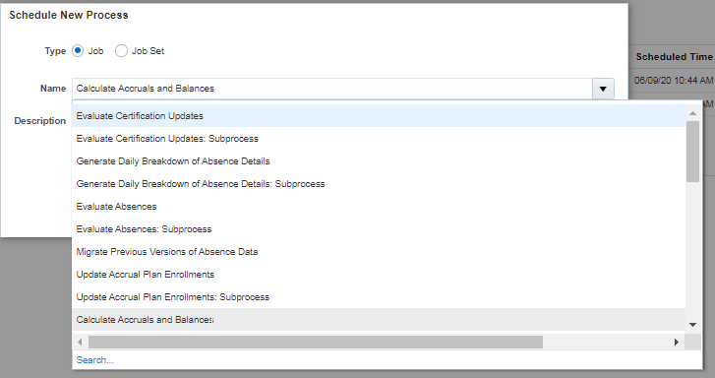

Click on ok to run the program

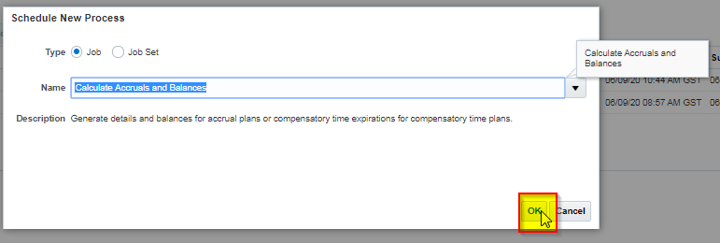

Enter following details and click on “Submit” Button

|  |  |
| --- | --- |
| Name | Calculate Accruals and Balances |
| Effective Date | 30/08/2020 |
| Process Selection Rule | ETC_ANNUAL_PLAN_REPROCESS |



Click on “Ok” Button

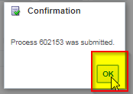

To verify the status of program in the next screen the program name status will be shown as “Succeeded” in the snapshot below

This closes the one time program to recalculate accruals

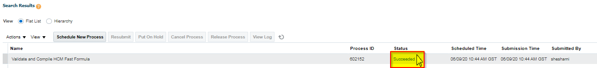

# Open and Closed Issues

1. Add open issues that you identify while writing or reviewing this document to the open issues section. As you resolve issues, move them to the closed issues section and keep the issue ID the same. Include an explanation of the resolution.  
     
   When this work product is complete, any open issues should be transferred to the project- or process-level Issue Log (Manage focus area) and managed using a project level Issue Form (Manage focus area). In addition, the open items should remain in the open issues section of this work product, but flagged in the resolution column as being transferred.

## Open Issues

| ID | Issue | Resolution | Responsibility | Target Date | Impact Date |
| --- | --- | --- | --- | --- | --- |
|  |  |  |  |  |  |
|  |  |  |  |  |  |
|  |  |  |  |  |  |
|  |  |  |  |  |  |

## Closed Issues

| ID | Issue | Resolution | Responsibility | Target Date | Impact Date |
| --- | --- | --- | --- | --- | --- |
|  |  |  |  |  |  |
|  |  |  |  |  |  |
|  |  |  |  |  |  |
|  |  |  |  |  |  |